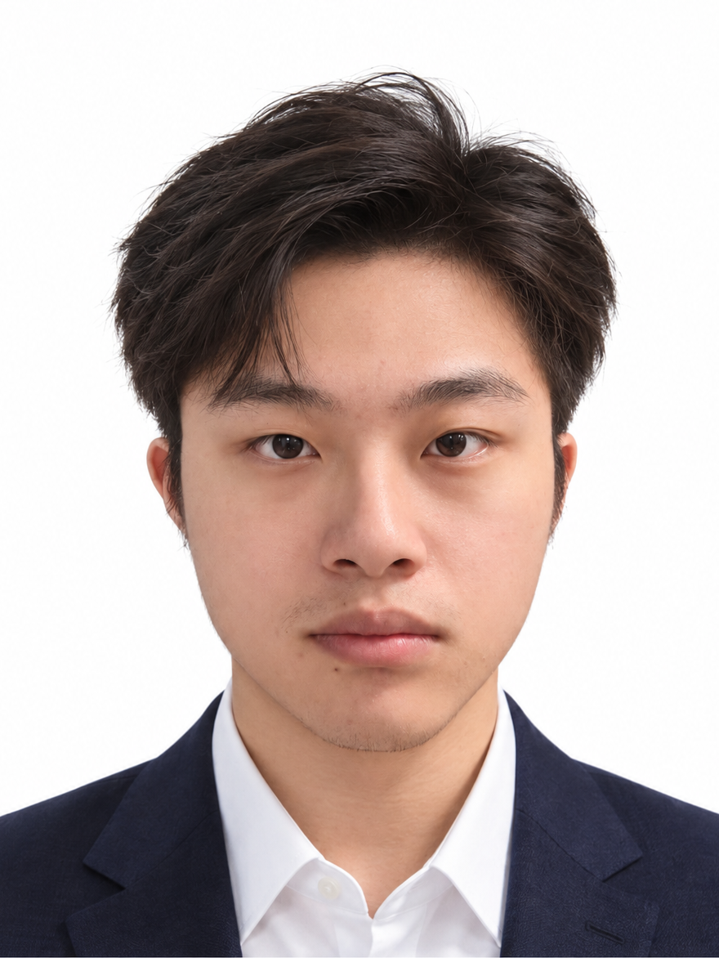  ADRIAN LV  Independent Developer  Founder of DuskRain  CONTACT  prdusk.com@gmail.com  duskrain.cn  github.com/ETO-ze  EDUCATION  Civil Aviation University  of China  Undergraduate studies  Aircraft Propulsion Engineering  Sep 2023 - Jun 2027  Expected graduation: Jun 2027  TECHNICAL SKILLS  Languages  Python, JavaScript, SQL  HTML/CSS, PowerShell  Web and backend  Vue 3, Vite, FastAPI, SQLite  REST APIs, OAuth  Desktop tools  PyInstaller, Windows utilities  USB CDC/UART  Device discovery and recovery  Raspberry Pi / embedded  Raspberry Pi 4B development  ESP32, MicroPython, I2C  OLED/LED, EasyEDA |  | SOFTWARE ENGINEERING  New Grad 2027 | Python & Full-Stack Development  PROFILE  Engineering undergraduate graduating in June 2027, targeting entry-level software engineering roles. Builds web applications, Windows utilities, and device integrations with Python, Vue 3, FastAPI, Raspberry Pi, and ESP32.  Founded DuskRain as a personal application platform. Project work covers implementation, deployment, account ownership, device recovery, and reproducible data workflows.  INDEPENDENT DEVELOPMENT  DuskRain | Founder and Independent Developer  2025 - Present | Personal technology platform  • Build and maintain personal application services, covering requirements, front-end and back-end implementation, deployment, releases, and ongoing maintenance.  • Configure access controls, reverse proxies, and runtime environments; separate public source from private credentials, configuration, and application data.  SELECTED PROJECTS  DuskRain Food Map  Full-stack dining and review application  Vue 3, Vite, FastAPI, SQLite, OAuth, Docker  github.com/ETO-ze/duskrain-food-map  • Built a dining database with map browsing, filters, mobile views, and an author workspace, combining AMap and Google POI data with locally managed ratings, photos, and Markdown reviews.  • Implemented visitor, author, and administrator permissions with stable account IDs for record ownership; added invitations, activation, password management, and Google/GitHub OAuth binding.  • Used Argon2id password hashing and OAuth state/PKCE; handled GCJ-02 and WGS84 coordinates and deployed behind a reverse proxy with Docker, separating runtime data and secrets from published source.  Codex OLED Status Display  Desktop software and embedded device integration  Python, MicroPython, RP2040-Zero, USB CDC, EasyEDA  github.com/ETO-ze/codex-oled-status-display  • Designed an OLED carrier PCB and developed MicroPython firmware to render task states, animations, and LED indicators on an RP2040-Zero and SH1106 display.  • Built a Python bridge that converts local Codex Desktop events into USB CDC messages; implemented serial discovery, reconnection, and state retransmission after device disconnects.  • Delivered a Windows preview, portable application, and installation/startup workflows; limited device messages to status fields and activity categories, excluding prompts, response bodies, and tool arguments.

ADRIAN LV  Projects and Additional Experience  DATA AND EXPERIMENTS  Libraries and models  TensorFlow, NumPy, SciPy  XGBoost, Random Forest  HistGradientBoosting  Workflows  Data preprocessing  Model-training workflows  CLI/YAML configuration  Backtesting and evaluation  Signal windowing and reconstruction  Integration  Third-party map and data APIs  Google/GitHub OAuth  Role permissions and record ownership  Deployment  Linux, Windows, Docker  Docker Compose, Git/GitHub  Nginx/OpenResty  Reverse proxies  OTHER APPOINTMENT  Chengdu Miaoyiyou  Technology Co., Ltd.  Supervisor  Corporate governance appointment  HONORS  Third Prize, Provincial Round  12th East Money Cup  National College Student  Financial Challenge  LANGUAGES  Mandarin Chinese: Native  English: CET-4  (College English Test, Band 4) |  | PROJECT EXPERIENCE  Desktop Systems | Data Workflows | Applied ML Tooling  HoloCubic Hub  Windows companion tools and firmware stability patches  Python, ESP32, USB, LVGL, PyInstaller  github.com/ETO-ze/holocubic-hub  • Developed desktop tooling and firmware patches for the HoloCubic/AIO ecosystem, unifying device configuration, Codex status bridging, and background operation in one Windows executable.  • Diagnosed access to destroyed LVGL objects during application transitions and adjusted surface recreation; corrected the order of readiness and first-frame acknowledgments in screen sharing.  • Corrected stale Wi-Fi connection state, serialized device operations to reduce serial-port contention, and added USB discovery and offline clock synchronization while preserving upstream attribution.  OpenClaw + Freqtrade  Research workflow and runtime control platform  Python, Freqtrade, Vue 3, Docker, XGBoost  github.com/ETO-ze/freqtrade-local  • Connected local market-data caching, dynamic universe screening, model training, backtesting, and approved configuration synchronization to a cloud Freqtrade runtime.  • Integrated Random Forest, HistGradientBoosting, and XGBoost for factor experiments; screened candidates using liquidity, market capitalization, volatility, funding rates, and BTC/ETH market conditions.  • Implemented approval checks using backtest returns, profit factor, drawdown, trade count, and concentration; built a read-only Vue dashboard and local GUI for inspection, process control, and synchronization.  DDAE Optimized  Engineering refactor of a seismic denoising workflow  TensorFlow, NumPy, SciPy, CLI, YAML  github.com/ETO-ze/DDAE_optimized  • Refactored an existing notebook-based DDAE implementation into CLI scripts, YAML configuration, and reusable data-processing workflows for supervised and self-supervised/unsupervised training.  • Added epsilon handling, clipping, and an optional MSE anchor to correlation-based loss; implemented trace-wise window extraction and overlap-add reconstruction to standardize training and reconstruction.  Alpha Sentinel Local  Local monitoring deployment and service integration  Python, FastAPI, SQLite, Docker Compose, Streamlit  github.com/ETO-ze/alpha_sentinel_local  • Integrated a local monitoring deployment with periodic token-list retrieval, change detection, alert records, health/status endpoints, and data-source controls.  • Organized services with Docker Compose and SQLite persistence; integrated trading-pair metrics and candlestick views, keeping the complete UI and private configuration separate from the partial public source.

