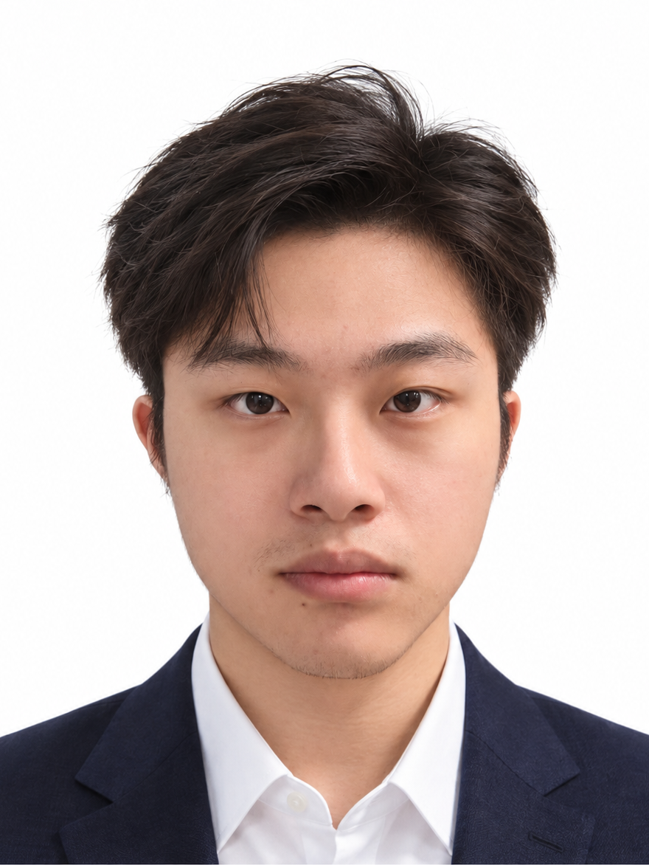  吕俊泽  Adrian Lv  DuskRain 创始人  独立开发者  联系信息  prdusk.com@gmail.com  duskrain.cn  github.com/ETO-ze  教育背景  中国民航大学  飞行器动力工程  本科在读  2023.09 - 2027.06  预计毕业  技术能力  语言与脚本  Python / JavaScript / SQL  HTML / CSS / PowerShell  Web 与后端  Vue 3 / Vite / FastAPI  SQLite / REST API / OAuth  桌面与设备  PyInstaller / USB CDC / UART  设备发现、重连与状态同步  树莓派与嵌入式  树莓派开发 / Raspberry Pi 4B  ESP32 / MicroPython / I²C  OLED / LED / EasyEDA  部署与维护  Linux / Windows / Docker  Docker Compose / Git / GitHub  Nginx / OpenResty / 反向代理 |  | 个人简历  Web 全栈 / 桌面软件 / 软硬件协同  个人简介  中国民航大学飞行器动力工程本科生，DuskRain 创始人、独立开发者。以 Python 为主要开发工具，结合 Vue 3、FastAPI、Docker、树莓派与 ESP32 开发，完成从应用实现、软硬件联调到部署分发的项目实践。  围绕实际需求开发 Web 应用、Windows 工具、嵌入式设备与数据实验流程，关注账户与数据归属、设备断连恢复、通信状态同步，以及系统持续维护和实验复现。  独立开发经历  DuskRain | 创始人、独立开发者  2025 - 至今 / 个人技术平台  • 创建并维护个人网站与应用服务，承担需求梳理、前后端开发、服务器部署、版本发布和日常维护。  • 配置账户访问、反向代理和运行环境，管理公开源码与私有凭据、配置及业务数据的边界，持续整合应用与工程作品。  代表项目  DuskRain Food Map  跨地图美食资料与评价系统  Vue 3 / Vite / FastAPI / SQLite / OAuth / Docker  GitHub / duskrain-food-map  • 独立开发地图浏览、条件筛选、移动端界面及作者工作台，将高德 / Google POI 与本站评分、图片和 Markdown 长评关联。  • 以稳定账户 ID 维护记录归属，区分访客、作者和管理员权限；实现邀请激活、密码管理和 Google / GitHub OAuth 绑定。  • 采用 Argon2id 密码哈希与 OAuth state / PKCE；处理 GCJ-02 / WGS84 坐标差异，并以 Docker 和反向代理部署。  Codex OLED Status Display  桌面任务状态显示设备  RP2040 / MicroPython / Python / USB CDC / EasyEDA  GitHub / codex-oled-status-display  • 设计 RP2040-Zero OLED 载板与接口布局，开发 MicroPython 固件，驱动 SH1106 状态画面、动画和三色 LED。  • 构建 Python 本地事件桥接与 USB CDC 通信，转换任务状态和任务计数；实现串口自动识别、重连与状态重发。  • 提供 Windows 预览、便携程序、安装与启动流程；限定设备协议字段，避免提示词、回复正文及工具参数传入外设。

Adrian Lv  吕俊泽 / 项目与实践  数据与实验  模型与科学计算  TensorFlow / NumPy / SciPy  XGBoost / Random Forest  HistGradientBoosting  实验工程  数据预处理与模型训练  CLI / YAML 配置  窗口提取与信号重建  回测、评估与结果展示  接口与账户  第三方地图与数据 API  Google / GitHub OAuth  角色权限与账户数据归属  其他任职  成都喵艺游科技有限公司  监事  荣誉与竞赛  第十二届“东方财富杯”  全国大学生金融挑战赛  省赛三等奖  语言能力  中文 / 母语  英语 / CET-4  更多作品  Authorized Digital Twin  Lumina CD Player  Remote Link Hub  WeChat Reply Helper  DuskRain Personal Site  github.com/ETO-ze |  | 项目经历  设备整合 / 数据工程 / 实验复现  HoloCubic Hub  Windows 设备工作台与固件稳定性补丁  ESP32 / Python / USB / LVGL / PyInstaller  GitHub / holocubic-hub  • 围绕 HoloCubic / AIO 生态开发桌面工具、协议整合与固件补丁，统一设备配置、Codex 状态桥接和后台运行。  • 定位应用切换时 LVGL 对象销毁后仍被访问的问题，调整界面重建；修正屏幕共享初始 ACK 与首帧 ACK 的处理顺序。  • 修正 Wi-Fi 断连后的过期连接状态，串行化设备操作以降低串口争用；实现 USB 发现、离线时钟同步与单文件分发。  OpenClaw + Freqtrade  量化研究与运行控制平台  Python / Freqtrade / Vue 3 / Docker / XGBoost  GitHub / freqtrade-local  • 围绕 Freqtrade 串联本地市场数据缓存、动态标的筛选、多模型训练、候选回测和云端配置同步。  • 结合流动性、市值、波动率、资金费率及 BTC / ETH 市场状态进行筛选，集成 Random Forest、HistGradientBoosting 与 XGBoost。  • 建立候选策略准入检查，综合收益、Profit Factor、回撤、交易数与集中度；以 Vue 只读看板和本地 GUI 展示状态、管理进程及同步审批后的配置。  DDAE Optimized  地震信号去噪实验工程化重构  TensorFlow / NumPy / SciPy / CLI / YAML  GitHub / DDAE_optimized  • 基于既有 DDAE 研究代码，将 Notebook 实验重构为 CLI 脚本、YAML 配置和可复用数据流程，组织监督与自监督 / 无监督训练阶段。  • 为相关性损失加入 epsilon、裁剪和可选 MSE anchor；实现逐道窗口提取与 overlap-add 重建，统一训练和重建流程。  Alpha Sentinel Local  市场监控服务本地部署与整合  Python / FastAPI / SQLite / Docker Compose / Streamlit  GitHub / alpha_sentinel_local  • 完成本地部署与接口整合，实现 TokenList 周期拉取、差异比较和告警记录，提供健康检查、状态查询与数据源控制接口。  • 集成交易对指标与 K 线展示；以 Docker Compose 组织服务，公开部分源码，并将完整 UI 与私有运行配置分开管理。

ADRIAN LV  Independent Developer  Founder of DuskRain  CONTACT  prdusk.com@gmail.com  duskrain.cn  github.com/ETO-ze  EDUCATION  Civil Aviation University  of China  Undergraduate studies  Aircraft Propulsion Engineering  Sep 2023 - Jun 2027  Expected graduation: Jun 2027  TECHNICAL SKILLS  Languages  Python, JavaScript, SQL  HTML/CSS, PowerShell  Web and backend  Vue 3, Vite, FastAPI, SQLite  REST APIs, OAuth  Desktop tools  PyInstaller, Windows utilities  USB CDC/UART  Device discovery and recovery  Raspberry Pi / embedded  Raspberry Pi 4B development  ESP32, MicroPython, I2C  OLED/LED, EasyEDA |  | SOFTWARE ENGINEERING  New Grad 2027 | Python & Full-Stack Development  PROFILE  Engineering undergraduate graduating in June 2027, targeting entry-level software engineering roles. Builds web applications, Windows utilities, and device integrations with Python, Vue 3, FastAPI, Raspberry Pi, and ESP32.  Founded DuskRain as a personal application platform. Project work covers implementation, deployment, account ownership, device recovery, and reproducible data workflows.  INDEPENDENT DEVELOPMENT  DuskRain | Founder and Independent Developer  2025 - Present | Personal technology platform  • Build and maintain personal application services, covering requirements, front-end and back-end implementation, deployment, releases, and ongoing maintenance.  • Configure access controls, reverse proxies, and runtime environments; separate public source from private credentials, configuration, and application data.  SELECTED PROJECTS  DuskRain Food Map  Full-stack dining and review application  Vue 3, Vite, FastAPI, SQLite, OAuth, Docker  github.com/ETO-ze/duskrain-food-map  • Built a dining database with map browsing, filters, mobile views, and an author workspace, combining AMap and Google POI data with locally managed ratings, photos, and Markdown reviews.  • Implemented visitor, author, and administrator permissions with stable account IDs for record ownership; added invitations, activation, password management, and Google/GitHub OAuth binding.  • Used Argon2id password hashing and OAuth state/PKCE; handled GCJ-02 and WGS84 coordinates and deployed behind a reverse proxy with Docker, separating runtime data and secrets from published source.  Codex OLED Status Display  Desktop software and embedded device integration  Python, MicroPython, RP2040-Zero, USB CDC, EasyEDA  github.com/ETO-ze/codex-oled-status-display  • Designed an OLED carrier PCB and developed MicroPython firmware to render task states, animations, and LED indicators on an RP2040-Zero and SH1106 display.  • Built a Python bridge that converts local Codex Desktop events into USB CDC messages; implemented serial discovery, reconnection, and state retransmission after device disconnects.  • Delivered a Windows preview, portable application, and installation/startup workflows; limited device messages to status fields and activity categories, excluding prompts, response bodies, and tool arguments.

ADRIAN LV  Projects and Additional Experience  DATA AND EXPERIMENTS  Libraries and models  TensorFlow, NumPy, SciPy  XGBoost, Random Forest  HistGradientBoosting  Workflows  Data preprocessing  Model-training workflows  CLI/YAML configuration  Backtesting and evaluation  Signal windowing and reconstruction  Integration  Third-party map and data APIs  Google/GitHub OAuth  Role permissions and record ownership  Deployment  Linux, Windows, Docker  Docker Compose, Git/GitHub  Nginx/OpenResty  Reverse proxies  OTHER APPOINTMENT  Chengdu Miaoyiyou  Technology Co., Ltd.  Supervisor  Corporate governance appointment  HONORS  Third Prize, Provincial Round  12th East Money Cup  National College Student  Financial Challenge  LANGUAGES  Mandarin Chinese: Native  English: CET-4  (College English Test, Band 4) |  | PROJECT EXPERIENCE  Desktop Systems | Data Workflows | Applied ML Tooling  HoloCubic Hub  Windows companion tools and firmware stability patches  Python, ESP32, USB, LVGL, PyInstaller  github.com/ETO-ze/holocubic-hub  • Developed desktop tooling and firmware patches for the HoloCubic/AIO ecosystem, unifying device configuration, Codex status bridging, and background operation in one Windows executable.  • Diagnosed access to destroyed LVGL objects during application transitions and adjusted surface recreation; corrected the order of readiness and first-frame acknowledgments in screen sharing.  • Corrected stale Wi-Fi connection state, serialized device operations to reduce serial-port contention, and added USB discovery and offline clock synchronization while preserving upstream attribution.  OpenClaw + Freqtrade  Research workflow and runtime control platform  Python, Freqtrade, Vue 3, Docker, XGBoost  github.com/ETO-ze/freqtrade-local  • Connected local market-data caching, dynamic universe screening, model training, backtesting, and approved configuration synchronization to a cloud Freqtrade runtime.  • Integrated Random Forest, HistGradientBoosting, and XGBoost for factor experiments; screened candidates using liquidity, market capitalization, volatility, funding rates, and BTC/ETH market conditions.  • Implemented approval checks using backtest returns, profit factor, drawdown, trade count, and concentration; built a read-only Vue dashboard and local GUI for inspection, process control, and synchronization.  DDAE Optimized  Engineering refactor of a seismic denoising workflow  TensorFlow, NumPy, SciPy, CLI, YAML  github.com/ETO-ze/DDAE_optimized  • Refactored an existing notebook-based DDAE implementation into CLI scripts, YAML configuration, and reusable data-processing workflows for supervised and self-supervised/unsupervised training.  • Added epsilon handling, clipping, and an optional MSE anchor to correlation-based loss; implemented trace-wise window extraction and overlap-add reconstruction to standardize training and reconstruction.  Alpha Sentinel Local  Local monitoring deployment and service integration  Python, FastAPI, SQLite, Docker Compose, Streamlit  github.com/ETO-ze/alpha_sentinel_local  • Integrated a local monitoring deployment with periodic token-list retrieval, change detection, alert records, health/status endpoints, and data-source controls.  • Organized services with Docker Compose and SQLite persistence; integrated trading-pair metrics and candlestick views, keeping the complete UI and private configuration separate from the partial public source.

